3D FIREBALL BALL BUMPER v1.1

## **Are there any more features and versions planned?** We will be updating the asset from time to time, check the asset store for updates and to see version notes by clicking on the version notes (ex: v1.2 etc).

**IMPORTANT REMINDER:** This is for the recent update of V1.1 with the new unity UI. Please note all the other old GUIs have been disabled in script with the // command.

**WHAT IS NEW?**

The package have been updated with the new UI so you can now easily create your own UI and we will even show you how. Now, in the player ball prefab (Player Ball Controller (Main Player & Game Settings) there is a ‘Ready-to-use In-Game UI’ which is set as the children of the player ball prefab.

This is the new UI that will show when the game wins or game ends. You can find the game win and end UI by clicking on the Ready-to-use In-Game UI > Canvas and there you have 2 children called ‘Complete Game Over UI’ and ‘Complete Game Won UI’. You can also set them to your needs. Be sure to enable them so you can see them because they will always be disabled at start and only enabled when the game is ends or when you win the game.

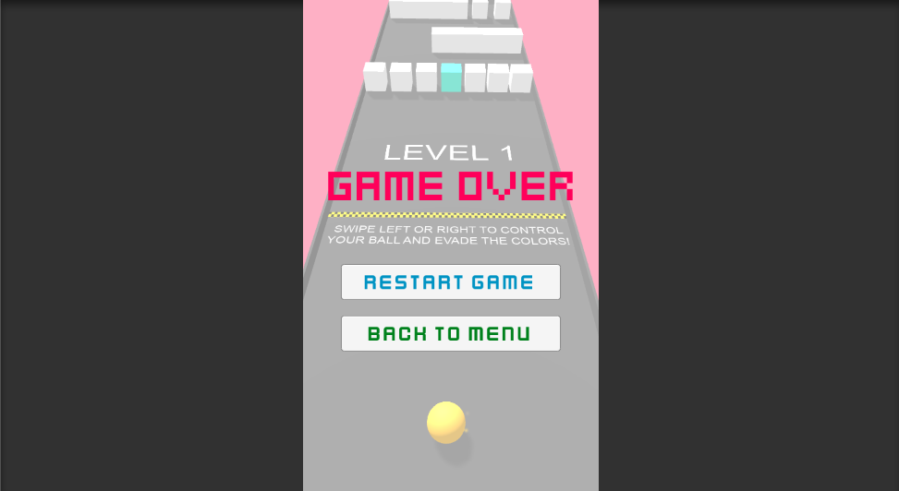

Now it’s easier to just edit the UI because you can just drag and drop using the UNITY UI and it’s as easy as ever and you can do so much more with it.

Be sure that in the (Player Ball Controller (Main Player & Game Settings) there is a ‘Ready-to-use In-Game UI’ which have a UI BUTTONS MANAGER, EVENTSYSTEM AND CANVAS. Then in canvas you have ‘Complete Game Over UI’ and ‘Complete Game Won’ UI. Be sure that they are in the player ball’s field in the inspector too!

**how to set up and change the new ui?**

Changing the UI is very easy now, as you can see you have the prefab called ‘Ready-to-use In-Game UI’ and this is the UI to display in-game with everything ready. All you need to do is drag-and-drop it into your scene and you can just edit them to your needs.

The Complete Game Over UI and Complete Game Won UI needs to be attached to the Player Ball Controller (Main Player & Game Settings) In the field where it says ‘Complete Game Over UI’ and ‘Complete Game Won UI’ this is important for the game over UI to appear.

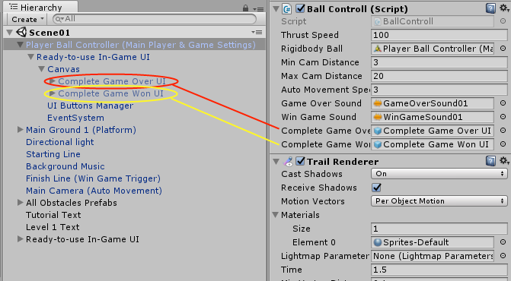

Well take this example with the Complete Game Over UI and everything applies for the other one, the Game Won UI. You can enable it (since it will always be disabled at start, because it will only be enabled when the game ends) so you can edit it to your needs. You can just select the buttons and move them around which you see fit along with the score and such. You can also change the name of the score by editing the script. All the scores have different script to calculate the score which you can edit to your needs.



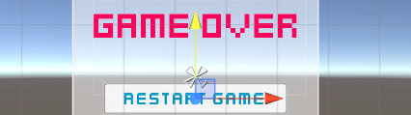

If you wish to customize the UI to your needs, then all you need to do is click on the tick to enable it (since it’s disabled because we want it to enable only when the player’s win or end the game) and you can move around the UI to your needs easily.

The most important ones are the ‘Complete Game Over UI’ which will appear when the game ends and the ‘Complete Game Won UI’ which will appear when the game is won. However, there are some other important ones which you need to know about.

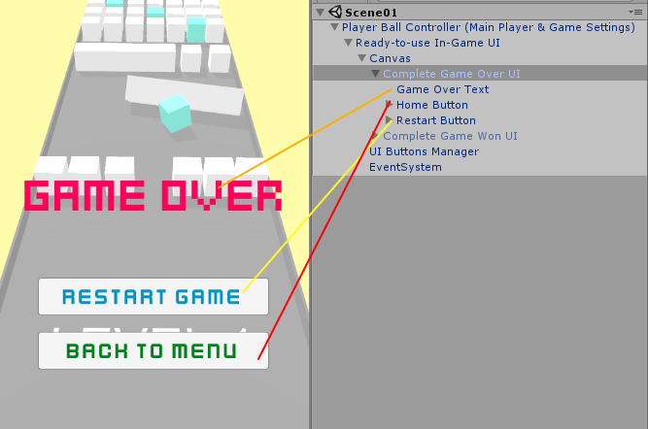

What about the other such as UI Buttons Manager and EventSystem?

It’s important that you have everything as it shown in the picture because the EventSystem is important and needed for the buttons and the UI Buttons Manager is also needed in order for you to be able to click on a button such as the ‘Restart Game’ button and such.

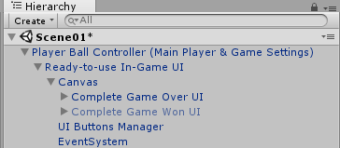

Be sure to always have the ‘Ready-to-use In-Game UI’ in your player with everything inside it.

**PLAYER UI EXPLAINED**

Now it’s time to explain the UI a little. Basically you should see a prefab called ‘Ready-to-use In-Game UI’ and this is the UI to display in-game with everything ready. That means with the game end screen, game win screen and the buttons. You can also customize them to your needs. **Be sure that you ALWAYS have this in each scene!**

In the package we updated the Player Ball prefab to include it in it as a children, but still check that you have it there just in case so you don’t really need to do anything as everything is still the same when building your game.



**Canvas:** The canvas is the canvas of the UI.

**Complete Game Over UI:** This is the complete game over UI which includes buttons and text for the game over screen. This is also hidden at start, if you wish to see how it looks in the game then just enable it.

**Complete Game Won UI:** This is the complete game over UI which includes buttons and text for the game win screen. This is also hidden at start, if you wish to see how it looks in the game then just enable it.



Inside these two important prefabs ‘Complete Game Won UI’ and ‘Complete Game Over UI’ you have a text which is the text that displays to show you that you won or lost the game and the buttons. This is the whole screen that will display when the game ends/wins. If you open it up you should see these which are the **Home Button** which can be clicked and you should be taken to your main menu, the **Restart Button** that when clicked you can restart the scene and on the ‘Complete Game Won UI’ only there should be the **Continue Button** so when you complete a level you can continue on to other levels. You can check the screenshot below to understand more.

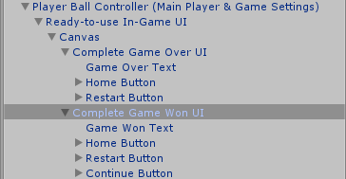

You can customize them to your needs, if you wish to change the TEXT for example instead you can and even the buttons. It’s all your choice.

**UI Buttons Manager:** This is the manager which manages all the buttons in-game and in the menu. For example if you click on the Restart Button when it appear at the end of the game it will restart the scene. This **is** needed and important in order for it to work. This prefab should have 5 scripts attached which are **RestartButton.cs**, **BackToMenu.cs**, **StartGameButton.cs**, **ExitButton.cs** and **ContinueButton.cs**.

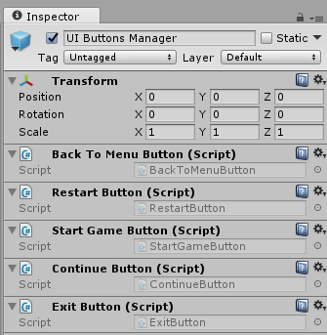

**EventSystem:** The eventsystem is needed and important because without it the buttons won’t work. Be sure that you ALWAYS have this in your scene.

Now as you know the UI works with the OnClick in the new unity when you are using the buttons.

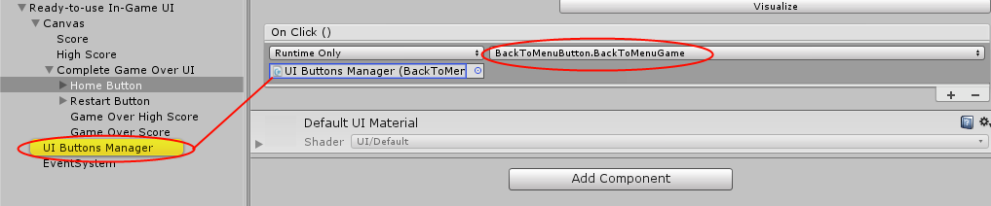

If you select the HOME BUTTON for example, you should at the bottom see On Click () and there you need to select the UI BUTTONS MANAGER since this will manage the buttons. Then in the next field where it says No Function select which script you wish to use when the button is pressed and select the script.

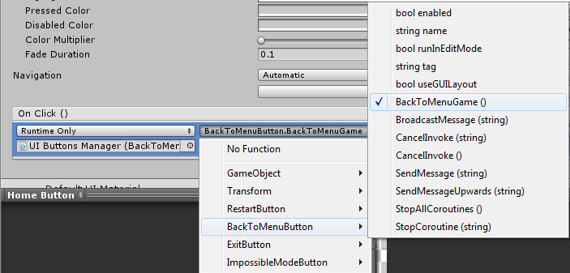

That is how you set up the buttons and such, the function are all called BackToMenuGame, RestartGame and so on. Hope you like the new update and enjoy!